Quality Plan

Cruz-Rabe Pharmacy Request System

1. Introduction
This document specifies the standards, responsibilities and specification of activities to ensure the quality and feasibility of the project. Quality goals and plans are integrated with overall strategic plans of the sponsored organization. As the projects, Cruz-Rabe Pharmacy Request System, consists of applicable procedures, applicable workmanship standards, the measurement tolerances acceptable, the description of the material standards and so forth.
Quality plan is also represented with other relevant document. Quality plans is defined as:
- Specific documents that are relevant to guarantee standards for further procedure and operation.
- Implementation should be able to meet the project objectives.
- Suitable testing, inspection, examination, and audit programs at appropriate stages
- A documented procedure for changes and modifications to a quality plan as a process is improved

2. Project Contractual Information

Project: | Cruz-Rabe Pharmacy Request System
Project Number: | 106
Program Co-ordinator: | Mrs. Carmelita Buenaflor
Principal Investigator(s): | Mr. Manuel Sebastian Sanchez
3. Scope of Work and Quality Objectives

Scope of work: | Pharmacy Request System is intended for pharmacists to use in their service that assists patients’ drug requests that is prescribed by a doctor. The patients will present their prescription given by the doctor into the nurse that will be processed by the pharmacist. The pharmacist will do request of orders that will be paid upon the cashier and billing section. Once the orders are paid, the orders will be ready to dispense to the patient. Alternatively, the Pharmacy Requests will be automated and the data will be on a database for data warehouse. On discharging In-Patients will be provided with their records as fast as possible. The stocks they took will be listed down on their records in real time. Therefore, in paying their bills, the process will take lesser time. This scheme will ease the work of the auditing staff and improve the discharging process of patients.
QA Requirement: | Software evaluation  Reviewing deliverables  Project testing (client and subjects)  Error and Bug reports  Having feedbacks and reviews

4. Project Organization

Project Manager(s): | Carl Dominique Bueno
Task Manager(s): | Glen Roy Rosales
Quality Assurance: | Carl Dominique Bueno
Other Team Members: | none
Subcontractors: | none
User Community: | Mrs. Carmelita Buenaflor  (Chief Pharmacists/Client)
Technical Reviews: | Mr. Jayvee Cabardo (project adviser)  Mr. Manuel Calimlim (project consultant)  Mr. Alfred Calimbo (project consultant

5. Project Duration and Scheduling

Start Date: | June 13, 2016 (starting from MSYSADD1)
Completion Date: | December 14, 2016 (end of CSPROJ2)
Scheduling of Activities

Gantt Chart
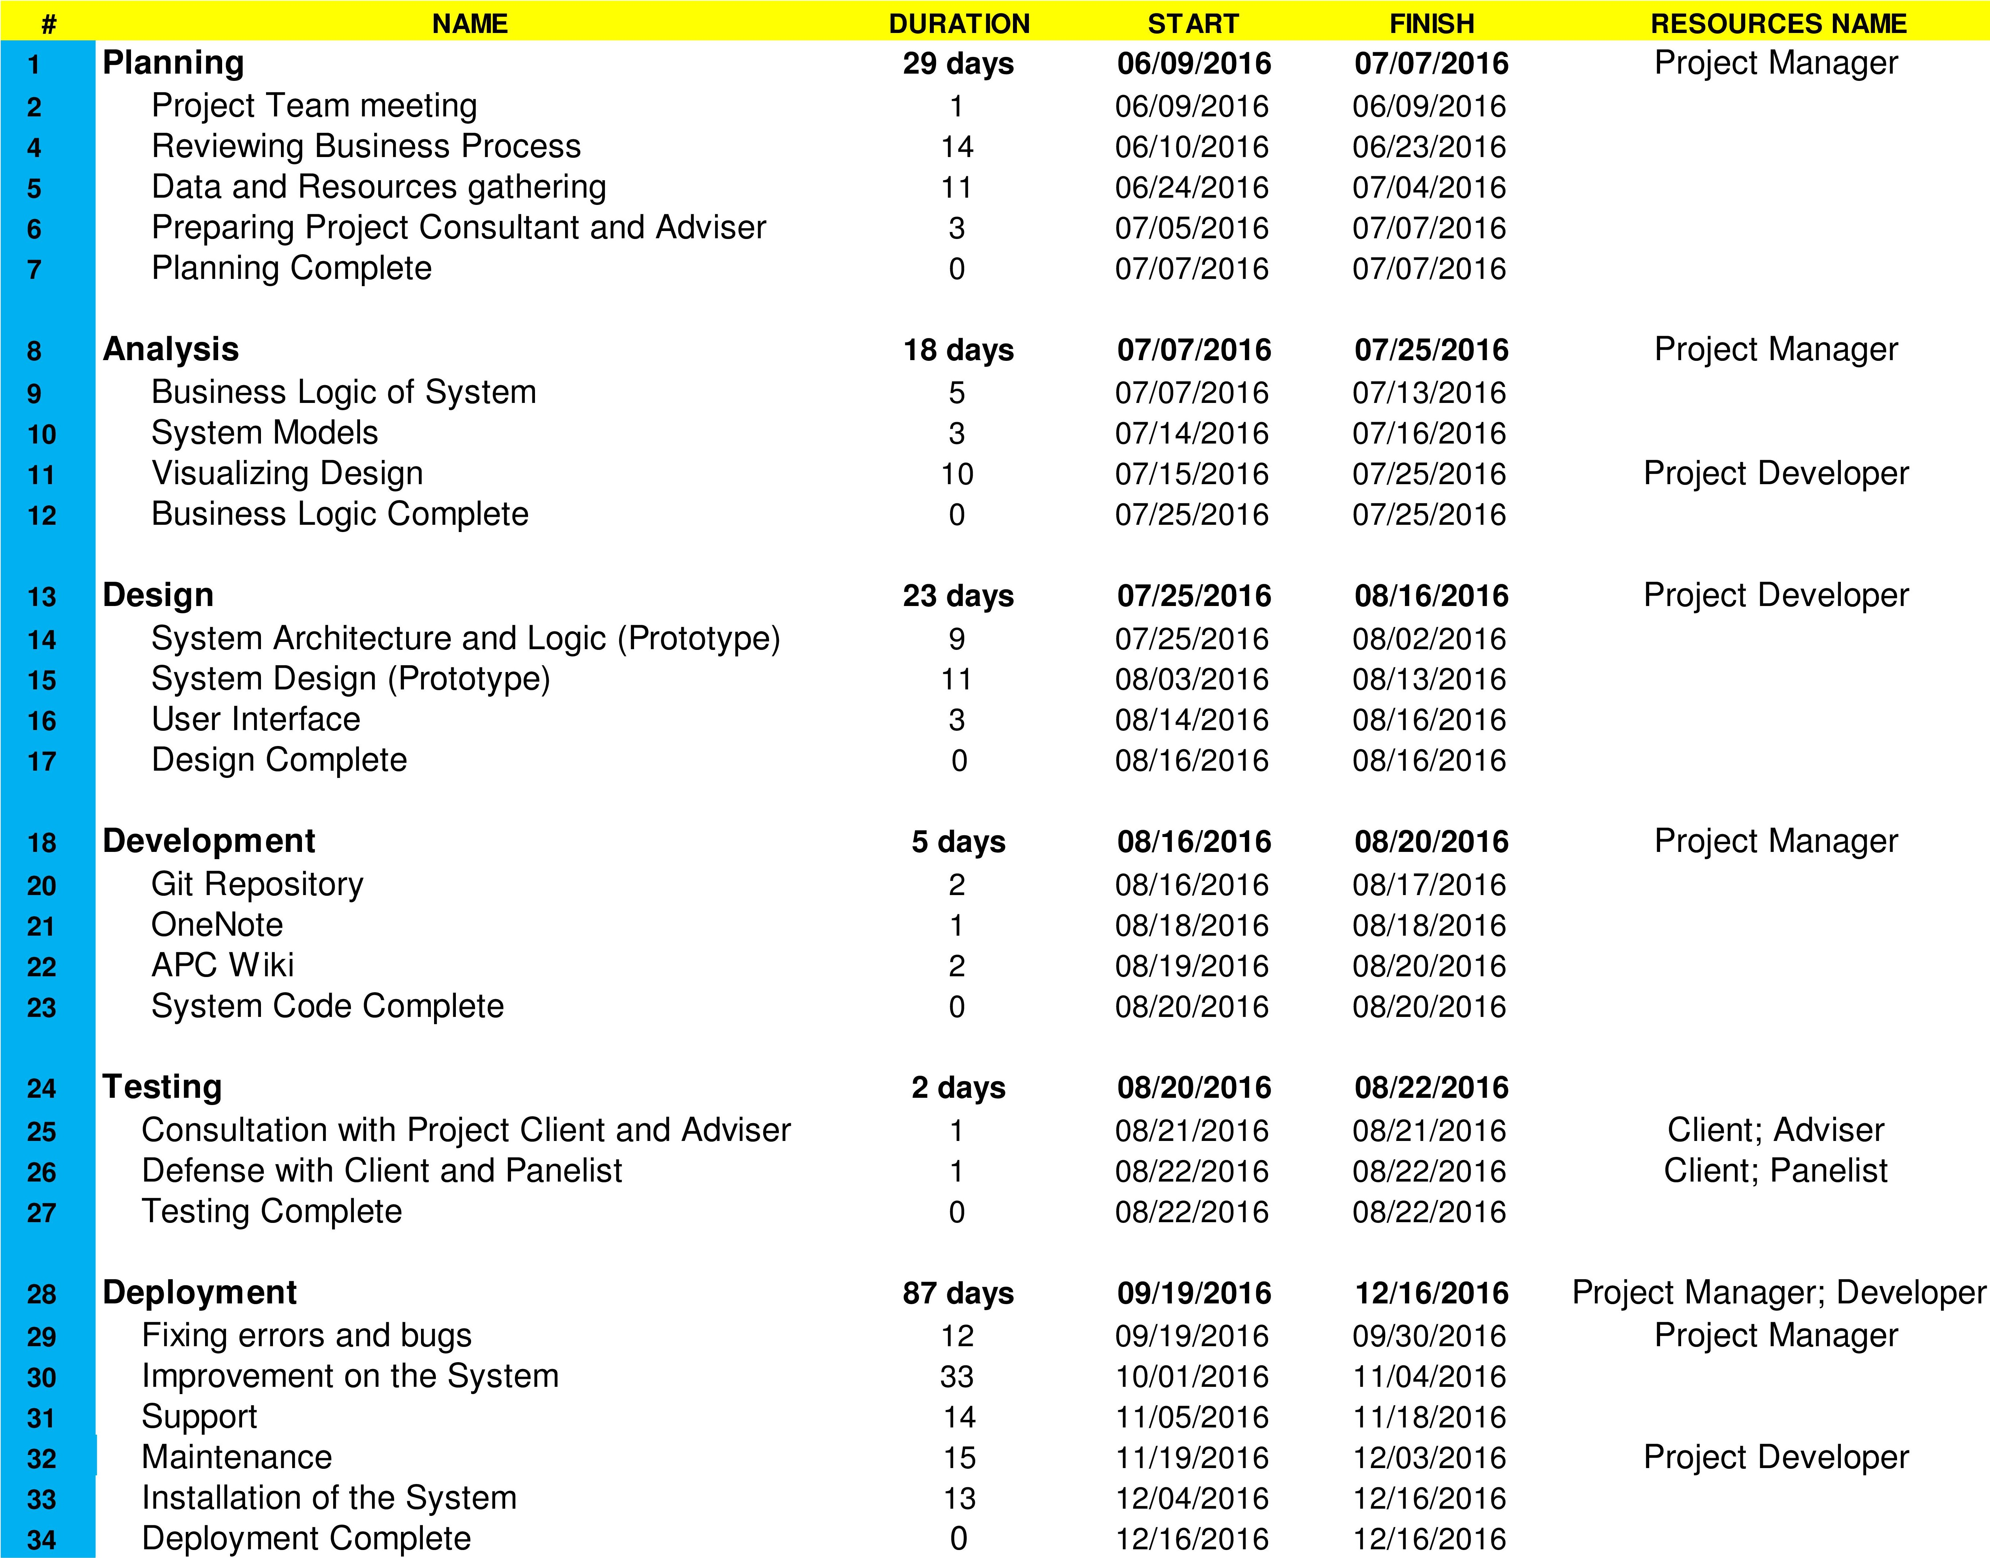

Work-Breakdown Structure

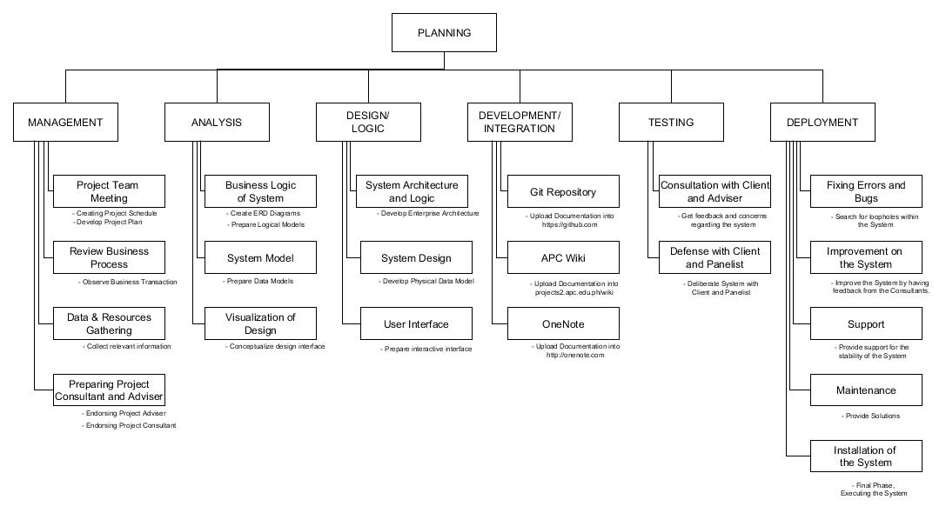

6. Deliverables
Deliverables specified for the project include:

- An acceptable Quality Plan
- An acceptable Data Management Plan
- An acceptable Project Documentation including models (tables & diagrams)
- An acceptable Project Plan
- An acceptable Work Breakdown Statement
- An acceptable Statement of Work Document
- An acceptable Gantt Chart and Activity List Model
- An acceptable Scope and Vision Document
- An acceptable Software Requirements Specification Document
- An acceptable Change Management Plan
- An acceptable Project Progress Reports

7. Review of Quality Plan
Specify how and how often this Quality Plan will be reviewed, e.g. every three months at consortium meetings

8. Document and Record Control

Project documents, progress reports, data models and software variables on previous and current works: INTSDEV, MSYSADD1 and MCSPROJ2 are compiled and distributed to GIT repository, OneNote, APC Wiki and Bluemix Cloud.

9. Documented Procedures
Give the references of any in-house and/or published methods or procedures used during the project. References need not include the issue/version number, providing that staff are informed separately of modifications to Procedures. Otherwise, provide a basic resume of methodology with an indication of how it will be archived for future reference. Any centrally administered documents that relate to quality assurance should also be referenced.

10. Additional Information
Unless included in associated technical procedures, any other information that has direct relevance to the quality of the product or service being provided should be included in the Quality Plan. This could include [add or delete as necessary]:
- special requirements for the procurement of services or goods, including subcontractors;
- additional procedures and controls for the review and verification of deliverables or other documents;
- special requirements for the identification and traceability of products, including, where applicable, the traceability of staff performing specific duties;
- special criteria for identifying the status of inspection and test products;
- minimum qualifications, training or experience required of staff to undertake certain activities, or any specialist staff training;
- process control requirements, including monitoring of activities;
- special procedures for the handling, storage, packaging, preservation and delivery of product;
- requirement for servicing of a product for which ongoing maintenance is required;
- specialist statistical techniques required.

Prepared by: Date:
Name: Carl Dominique Bueno

Checked by: Date:
Name: Jayvee Cabardo

Approved by: Date:
Name: Manual Sanchez

